Practical No. 1
Aim: OSPF Implementation
a) Implement Single-Area OSPFv2
b) Implement Multi-Area OSPFv2
Introduction:
OSPF (Open Shortest Path First) is a routing protocol that uses a link-state algorithm, while Single-Area OSPFv2 is a simple implementation where all routers are in one area, and Multi-Area OSPFv2 is a more scalable hierarchical design where the network is split into areas, with Area 0 as the backbone
Single-Area OSPFv2
- Description: All routers in the network are configured within a single OSPF area, typically Area 0.
- Configuration: This is the simplest OSPF setup, involving enabling the OSPF process, configuring a router ID, and enabling OSPF on the interfaces.
Multi-Area OSPFv2
- Description: The network is divided into multiple areas, with all areas connected to the backbone area (Area 0). Routers connecting different areas are called Area Border Routers (ABRs).
- Configuration: More complex than single-area OSPF, as it requires a hierarchical design and the configuration of multiple areas, with specific roles for routers like ABRs.

STEPS FOR SINGLE-AREA OSPFv2:
Step 1: Open Cisco Packet Tracer, go to Network devices > Routers > add 3 routers of 1841.
Step 2: Now click on Router0 > Switch off the button > add WIC-2T > Switch On. Do the same for remaining Routers.
Step 3: Go to Connections > select Serial DCE and connect the routers with serial 0/0/0 to serial 0/0/1.
Step 4: Go to Network devices > Switches > add 3 switches of 2960. One Switch for one Router.
Step 5: Go to End Devices > add 3 PCs to each switch.
Step 6: Go to Connections > choose first wire > connect Router to Switch and Switch to PC.
Step 7: Assigning IP address to serial, click on router > config > serial port > checkbox on > clock rate to 64000 then assign IP address and for fastEathernet, click on router > config > fastEathernet port > checkbox on then assign IP address.
Step 8: Assigning IP address to PCs, click on PC > Desktop > IP Configuration > assign IP address and Default Gateway (i.e. the fastEathernet IP connected to the switch), then the final topology with IP addresses will look like:
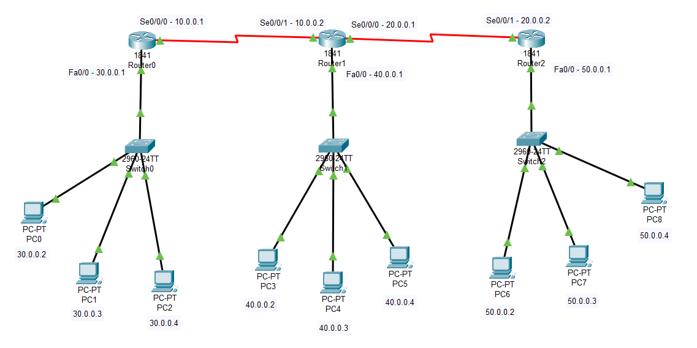
Step 9: To implement Single-Area OSPFv2, click on Respective Routers then go to CLI tab then execute commands run commands with their respective routers:

Router0: Router>enable
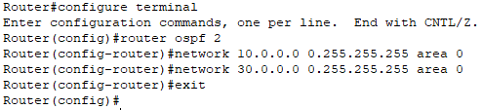

Router1: Router>enable
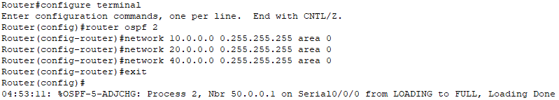

Router2: Router>enable
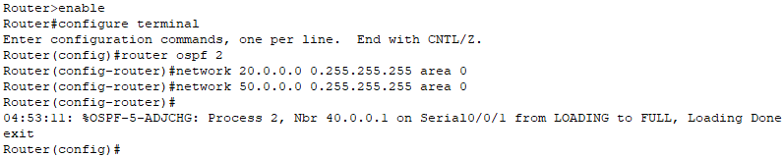
PC1: PC8:
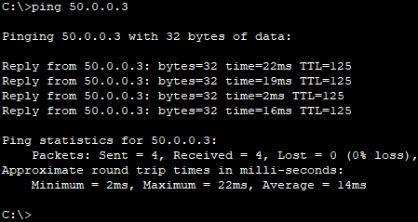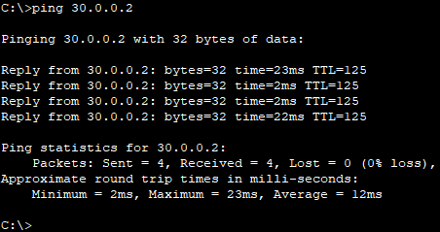
STEPS FOR MULTI-AREA OSPFv2:
Step 1: Open Cisco Packet Tracer, go to Network devices > Routers > add 3 routers of 1841.
Step 2: Now click on Router0 > Switch off the button > add WIC-2T > Switch On. Do the same for remaining Routers.
Step 3: Go to Connections > select Serial DCE and connect the routers with serial 0/0/0 to serial 0/0/1.
Step 4: Go to Network devices > Switches > add 3 switches of 2960. One Switch for one Router.
Step 5: Go to End Devices > add 2 PCs to each switch.
Step 6: Go to Connections > choose first wire > connect Router to Switch and Switch to PC.
Step 7: Assigning IP address to serial, click on router > config > serial port > checkbox on > clock rate to 64000 then assign IP address and for fastEathernet, click on router > config > fastEathernet port > checkbox on then assign IP address.
Step 8: Assigning IP address to PCs, click on PC > Desktop > IP Configuration > assign IP address and Default Gateway (i.e. the fastEathernet IP connected to the switch), then the final topology with IP addresses will look like:
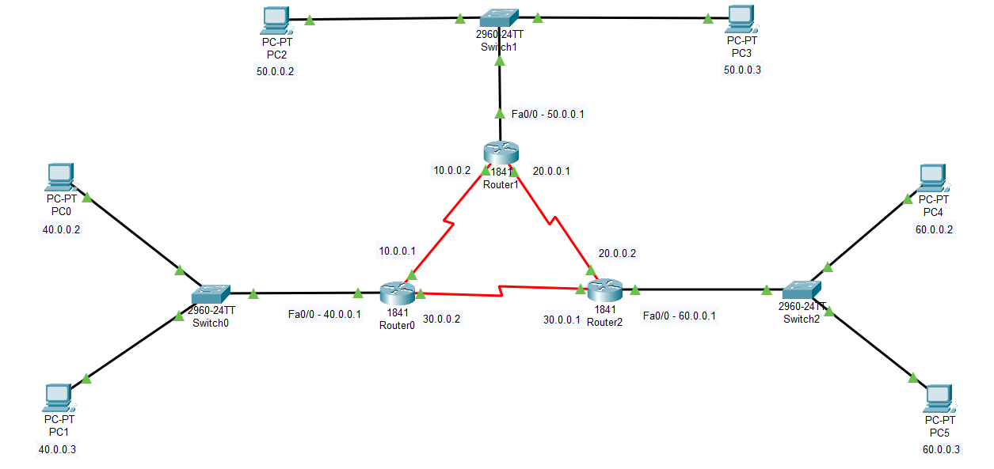
Step 9: To implement Multi-Area OSPFv2, click on Respective Routers then go to CLI tab then execute commands run commands with their respective routers:

Router 0:
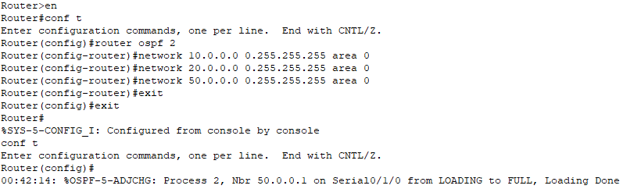
Router 1:
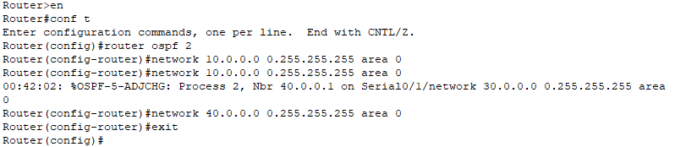
Router 2:
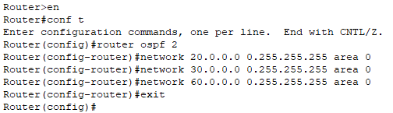
PC0: PC4:
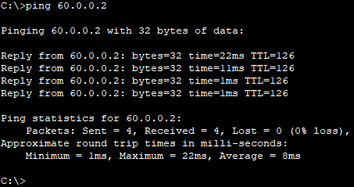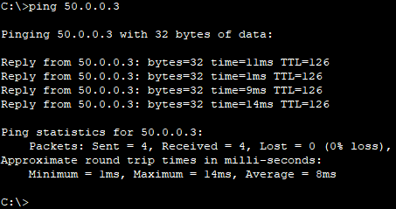
Practical No. 2
Aim: Implement BGP communities.
Introduction:
Border Gateway Protocol (BGP) refers to a gateway protocol that enables the internet to exchange routing information between autonomous systems (AS). As networks interact with each other, they need a way to communicate. This is accomplished through peering. BGP makes peering possible. Without it, networks would not be able to send and receive information with each other. When you have a network router that connects to other networks, it does not know which network is the best one to send its data to. BGP takes into consideration all the different peering options a router has and chooses the one that is closest to where the router is.
- Function: BGP's main purpose is to exchange routing information to find the best path for data traveling across different networks on the internet.
- Autonomous Systems (AS): The internet is made up of many ASs, and BGP is the protocol used to manage routing between them.
- Route selection: Unlike some other protocols that simply find the shortest path, BGP is designed for the scale of the internet and can be configured to use more complex policies to choose the best route.
- Connection: BGP routers establish TCP connections over port 179 to communicate with each other and exchange routing data.
- Internal vs. External: BGP can be used for routing within an AS (iBGP) or between different ASs (eBGP).

Step 1: Open Cisco Packet Tracer, go to Network devices > Routers > add 3 routers of 1841.
Step 2: Now click on Router0 > Switch off the button > add WIC-2T > Switch On. Do the same for remaining Routers.
Step 3: Go to Connections > select Serial DCE and connect the routers with serial 0/0/0 to serial 0/0/1.
Step 4: Go to End Devices > add 1 PC to each router.
Step 5: Go to Connections > choose first wire > connect Router to PC.
Step 6: Assigning IP address to serial, click on router > config > serial port > checkbox on > clock rate to 64000 then assign IP address and for fastEathernet, click on router > config > fastEathernet port > checkbox on then assign IP address.
Step 7: Assigning IP address to PCs, click on PC > Desktop > IP Configuration > assign IP address and Default Gateway (i.e. the fastEathernet IP connected to the switch), then the final topology with IP addresses will look like:
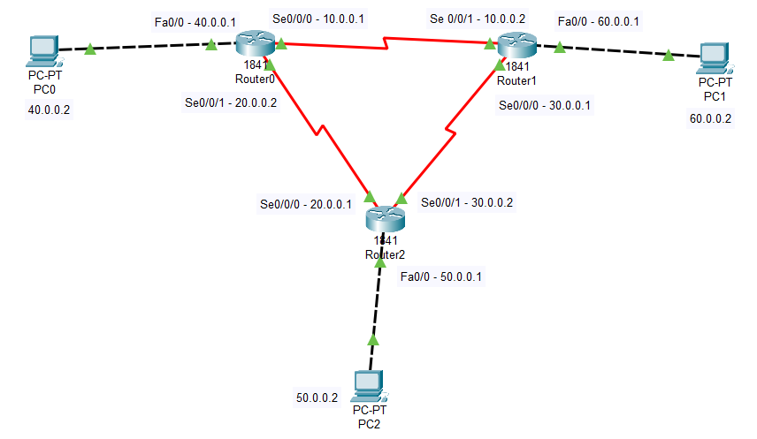
Step 8: To implement BGP, click on Respective Routers then go to CLI tab then execute commands run commands with their respective routers:

Router0:
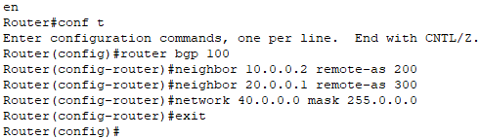
Router1:
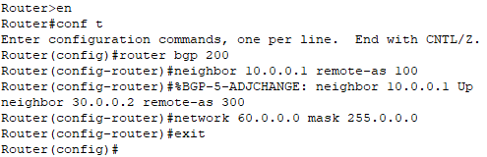
Router2:
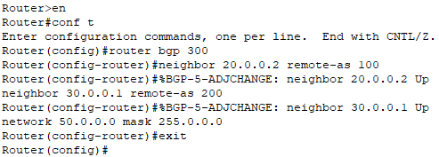
PC1:
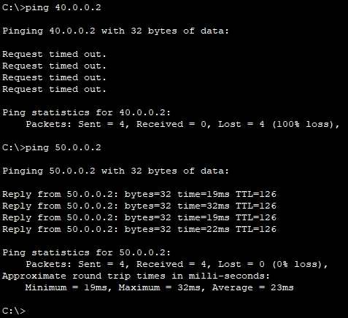
Practical No. 3
Aim: Access Control List (ACL):
  - Standard ACL
  - Extended ACL
Introduction:
Access Control List (ACL) refers to a specific set of rules used for filtering network traffic, especially in computer security settings. ACLs also allow specific system objects such as directories or file access to authorized users and denies access to unauthorized users.
ACLs are mainly found in network devices with packet filtering capabilities including routers and switches.

Standard ACL:
This type allows you to only evaluate packet source IP addresses. They are not as powerful as extended ACLs but use less computing power. They also use numbers 1300-1999 or 1-99 so that the router can identify the specific address as the source IP address.

Extended ACL:
These types of ACL allow you to block source and destination for specific hosts or thewhole network. With Extended ACLs it's possible to filter traffic based on protocols (IP, TCP, ICMP, and UDP).
Step 1: Open Cisco Packet Tracer, go to Network devices > Routers > add 3 routers of 1841.
Step 2: Now click on Router0 > Switch off the button > add WIC-2T > Switch On. Do the same for remaining Routers.
Step 3: Go to Connections > select Serial DCE and connect the routers with serial 0/0/0 to serial 0/0/1.
Step 4: Go to End Devices > add 1 PC to each router.
Step 5: Go to Connections > choose first wire > connect Router to PC.
Step 6: Assigning IP address to serial, click on router > config > serial port > checkbox on > clock rate to 64000 then assign IP address and for fastEathernet, click on router > config > fastEathernet port > checkbox on then assign IP address.
Step 7: Assigning IP address to PCs, click on PC > Desktop > IP Configuration > assign IP address and Default Gateway (i.e. the fastEathernet IP connected to the switch), then the final topology with IP addresses will look like:
Step 8: Commands for Standard ACL: go to second (Router1) router and run
Router>en
Router#conf t
Router(config)#access-list 1 deny 40.0.0.2 0.0.0.0
Router(config)#access-list 1 permit any
Router(config)#interface Fa0/0
Router(config-if)#ip access-group 1 out
Router(config-if)#exit
Router(config)#exit
Router#show access-list
Router1:
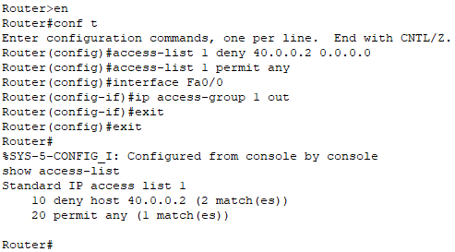
PC1:
Step 9: Commands for Extended ACL: go to second (Router1) router and run
Router>en
Router#conf t
Router(config)#access-list 101 deny tcp 40.0.0.2 0.0.0.0 50.0.0.2 0.0.0.0 eq 80
Router(config)#access-list 101 permit ip any any
Router(config)#interface Fa0/0
Router(config-if)#ip access-group 101 in
Router(config-if)#exit
Router(config)#exit
Router#show access-list
Router1:
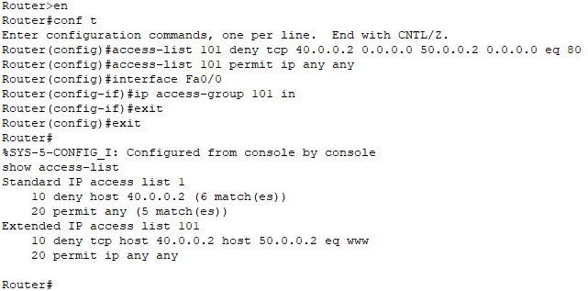
PC1:
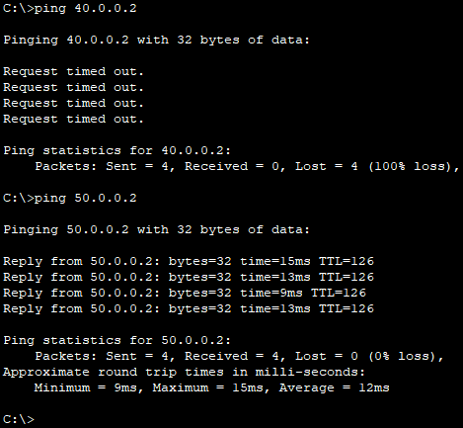

Practical No. 4
Aim: Implement Inter-VLAN Routing:
Introduction:
Inter-VLAN routing is a method that allows communication between different VLANS (Virtual Local Area Networks) within a network. VLANs are used to segment a network into smaller, isolated broadcast domains to improve performance and security. However, by default, devices in separate VLANs cannot communicate with each other because each VLAN is treated as a separate network. Inter-VLAN routing enables data exchange between these segmented networks.

How it works
- VLANs and isolation: VLANs segment a network into logical groups, and devices within a VLAN can communicate freely, but they cannot communicate with devices in other VLANs by default.
- The need for routing: To enable communication between VLANs, a device capable of routing is required. This device acts as the default gateway for devices on each VLAN.
- The routing process: When a device sends traffic to a different VLAN, it sends the packet to its default gateway (the router or Layer 3 switch). The gateway then uses the destination IP address to route the packet to the correct destination VLAN.

Step 1: Open Cisco Packet Tracer, go to Network devices > Routers > add 3 routers of 1841.
Step 2: Now click on Router0 > Switch off the button > add WIC-2T > Switch On. Do the same for remaining Routers.
Step 3: Go to Connections > select Serial DCE and connect the routers with serial 0/0/0 to serial 0/0/1.
Step 4: Go to Network devices > Switches > add 3 switches of 2960. One Switch for one Router.
Step 5: Go to End Devices > add 2 PCs to each switch.
Step 6: Go to Connections > choose first wire > connect Router to Switch and Switch to PC.
Step 7: Assigning IP address to serial, click on router > config > serial port > checkbox on > clock rate to 64000 then assign IP address and for fastEathernet, click on router > config > fastEathernet port > checkbox on then assign IP address.
Step 8: Assigning IP address to PCs, click on PC > Desktop > IP Configuration > assign IP address and Default Gateway (i.e. the fastEathernet IP connected to the switch), then the final topology with IP addresses will look like:
Step 9: To implement V-LAN, first go to router 0,1,2 > Config > RIP > add IP addresses:
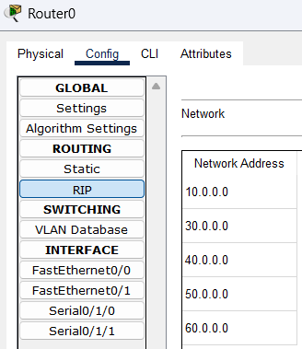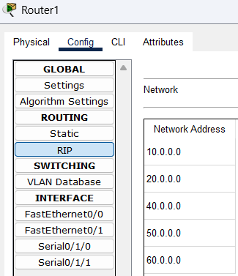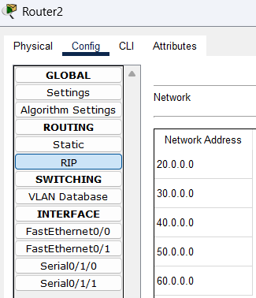
Step 10: Now click on any one switch > go to CLI and run following commands:

Switch>en
Switch#conf t
Switch(config)#vlan 10
Switch(config-vlan)#name administration-Department
Switch(config-vlan)#exit
Switch(config)#vlan 20
Switch(config-vlan)#name operation-Department
Switch(config-vlan)#exit
Switch(config)#vlan 30
Switch(config-vlan)#name HR-Department
Switch(config-vlan)#exit
Switch(config)#exit
Switch#show vlan brief

